Lab Experiment: Basic Image Handling and Processing Operations
Experiment No: 1
Aim
To read an image using Python and convert the image into grayscale using the OpenCV library.
Tools Required
- Python 3.x
- OpenCV (cv2)
- NumPy
- VS Code / PyCharm / Jupyter Notebook
- Input Image
Procedure
- Install the OpenCV library using:
- Import the required library (cv2).
- Read the input image using cv2.imread().
- Display the original image.
- Convert the image into grayscale using cv2.cvtColor().
- Display the grayscale image.
- Wait for a key press and close all image windows.

Code

import cv2

# Step 1: Read the image

image = cv2.imread("sample.jpeg") # Replace with your image file name

# Check if image is loaded properly

if image is None:

print("Error: Image not found!")

else:

# Step 2: Convert image to Gray-scale

gray_image = cv2.cvtColor(image, cv2.COLOR_BGR2GRAY)

# Step 3: Display the images

cv2.imshow("Original Image", image)

cv2.imshow("Gray-scale Image", gray_image)

# Wait until a key is pressed

cv2.waitKey(0)

# Close all windows

cv2.destroyAllWindows()

Output
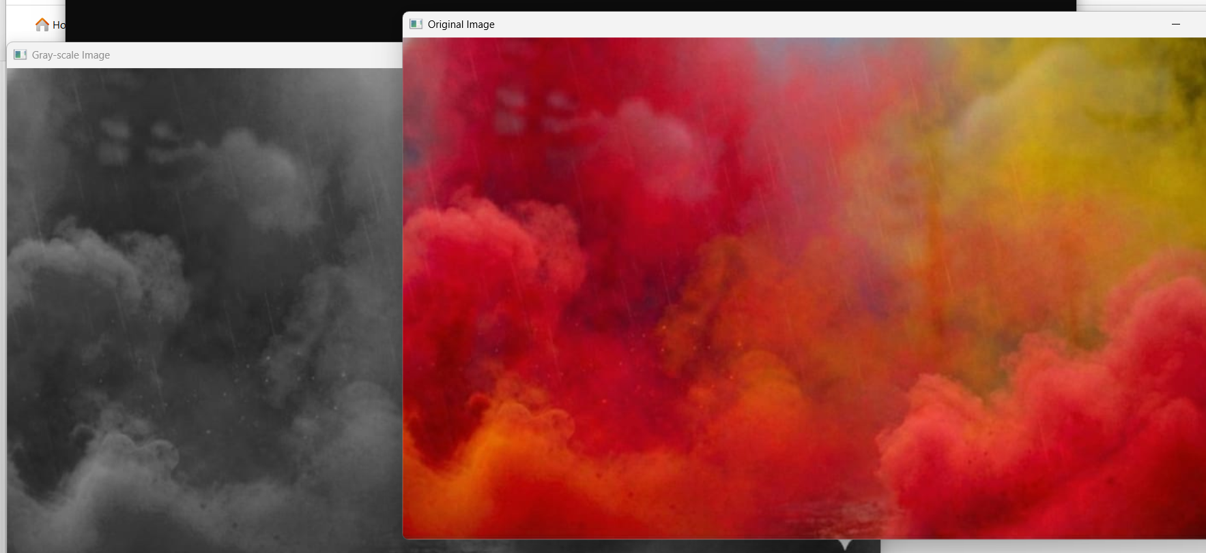
Result
The input image was successfully read using Python, and the color image was converted into a grayscale image using the OpenCV library. The grayscale image was displayed successfully.

